Lab 4
MSDS684_S70_Reinforcement Learning
Maryi Tatiana Palacios Giraldo
Regis University
April 2026

Project Overview
This project explores Temporal-Difference (TD) learning methods, focusing on two fundamental control algorithms: SARSA and Q-learning. The objective is to understand how these algorithms learn optimal policies through interaction with an environment, specifically using the CliffWalking-v0 environment from Gymnasium.
The key goal is to analyze the difference between on-policy (SARSA) and off-policy (Q-learning) learning, and how this affects agent behavior, learning stability, and performance.

Deliverables
GitHub Repository:
https://github.com/MPalacios-Analytics/DataScience_Projects/tree/91f9c873f767025a209ca38b01085d079c12c75b/06_Reinforcement_Learning/Lab_4
Implementation Summary
Both SARSA and Q-learning were implemented using NumPy-based Q-tables indexed by state and action pairs. The agent interacts with the environment using an ε-greedy policy to balance exploration and exploitation.
The algorithms were implemented with online updates, meaning Q-values were updated after every step rather than at the end of each episode. This aligns with the core idea of Temporal-Difference learning, where updates are made incrementally using bootstrapping.
To ensure robust results, each algorithm was run across 30 different random seeds. Learning curves were generated by computing the average reward per episode along with 95% confidence intervals.

Key Results & Analysis
The learning curves show that both SARSA and Q-learning significantly improve performance over time, starting with very low rewards and converging toward near-optimal behavior.
Q-learning converges slightly faster and achieves marginally higher final rewards, indicating that it learns a more optimal policy. However, it also exhibits more variability during training.
In contrast, SARSA demonstrates smoother and more stable learning behavior. While it may converge slightly slower, it avoids extreme negative rewards more effectively, especially during early exploration.
This difference is explained by their learning strategies. SARSA is an on-policy method that updates its Q-values based on the action actually taken, including exploratory actions. As a result, it learns safer policies that avoid risky states such as the cliff.
Q-learning, on the other hand, is an off-policy method that updates using the maximum possible future reward, regardless of the action taken. This leads to more aggressive optimization and a preference for the shortest path, even if it involves higher risk.

Visualizations
Learning Curves: Show the improvement in rewards over episodes, including confidence intervals:
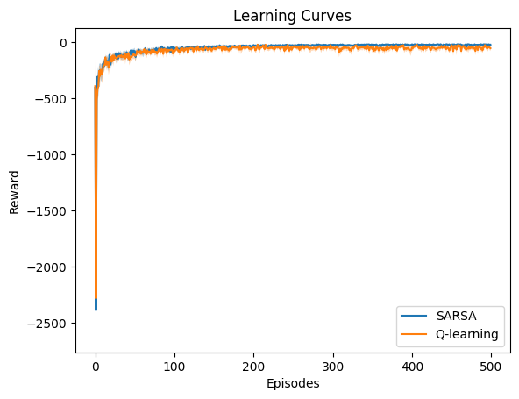
- From the results, both SARSA and Q-learning improve significantly over time,
moving from very low rewards at the beginning to near-optimal performance.
- Q-learning appears to converge slightly faster and reaches marginally higher rewards, indicating it learns a more optimal policy.
- SARSA, while slightly slower, shows smoother and more stable learning behavior, suggesting it is less sensitive to risky exploration.

Value Function Heatmaps: Illustrate how each algorithm values different states in the grid.
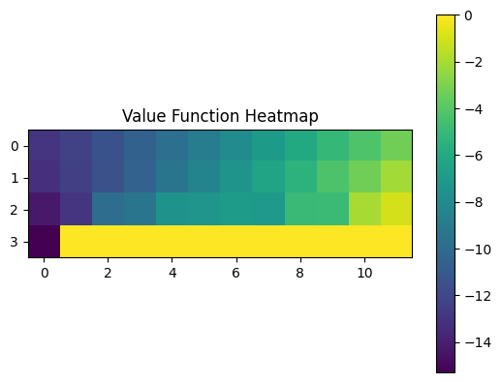
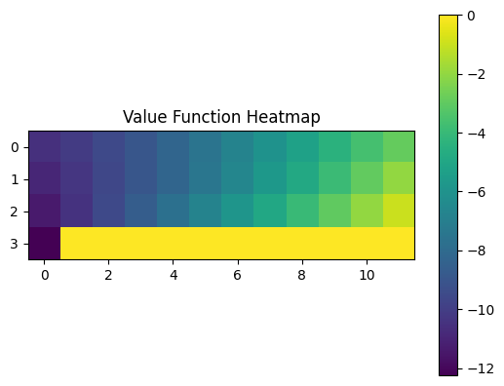
The policies learned suggest that both algorithms identify efficient paths to the goal. However, SARSA’s policy tends to avoid the cliff region more, while Q-learning follows a more direct route, even if it is closer to danger.

Policy Representation: Displays the preferred action in each state.
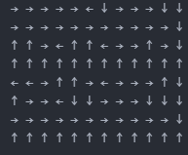

The arrows demonstrate that SARSA learns a conservative and safer policy, while Q-learning learns a more optimal but riskier path.

Sample Trajectories: Demonstrate how the agent navigates from start to goal.
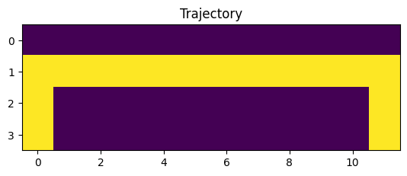
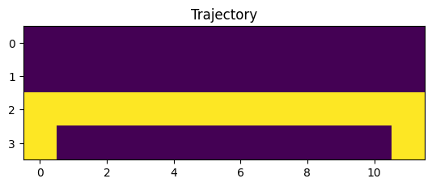
- The trajectories confirm the behavioral differences between the algorithms.
- SARSA follows a safer path that keeps distance from the cliff, reducing the risk of large negative rewards.
- Q-learning takes a shorter and more direct path toward the goal, which is optimal but passes closer to the cliff, making it riskier.
The visualizations confirm that SARSA tends to avoid the cliff by following a safer route, while Q-learning takes a more direct but riskier path closer to the cliff.
Conclusion
This project highlights the fundamental trade-off between safety and optimality in reinforcement learning. SARSA, as an on-policy method, produces safer and more stable behavior by incorporating exploration into its updates. In contrast, Q-learning prioritizes optimality, achieving higher rewards but at the cost of increased risk during learning.
These findings demonstrate the importance of selecting the appropriate learning strategy depending on the problem context, particularly in environments where safety is a critical concern.
AI Use Reflection
AI tools were used as a support resource throughout this assignment.
Initial Interaction:
The first interaction involved asking for clarification on the requirements of the assignment, particularly the differences between SARSA and Q-learning, and how to structure the implementation using Gymnasium.
Use During Development:
AI was used to better understand how to implement Temporal-Difference updates, structure the training loops, and correctly handle elements such as ε-greedy policies, environment step outputs, and terminal states.
AI was also helpful in debugging minor issues and ensuring correct implementation of formulas for both algorithms.
Critical Evaluation:
All suggestions provided by AI were carefully reviewed and tested. The final implementation reflects my own understanding of the algorithms, and I ensured that I could explain each component of the code and the results obtained.
Speaker Notes
- This project explores Temporal Difference learning using SARSA and Q-learning
- The goal is to compare on-policy vs off-policy learning
- We use the CliffWalking environment
- Both algorithms use Q-tables with NumPy
- We apply ε-greedy exploration
- We ran 30 seeds for reliable results
- Both algorithms improve over time
- Q-learning converges faster and reaches slightly higher rewards
- SARSA is more stable during training
- Heatmaps show value distribution across states
- Trajectories show how the agent moves
- SARSA avoids the cliff
- Q-learning takes a shorter but riskier path
- SARSA = on-policy - safer
- Q-learning = off-policy - more optimal
- Trade-off: safety vs performance
- SARSA is better for safety-critical environments
- Q-learning is better when optimal performance is the goal
- Choosing the right algorithm depends on the problem

